Chapter 7
Mycorrhizae
One of the most well-studied examples of mutualistic symbiosis, where both partners benefit, is the relationship between land plants and mycorrhizal fungi. Researchers hypothesize that these fungi, which reside on or in the roots of plants to help them acquire water and nutrients, played a crucial role in enabling plants to transition from aquatic environments to land (Bonfante and Genre 2008). This relationship has been evolving for hundreds of millions of years, which is reflected in the fact that the majority of land plants form some sort of intimate partnership with mycorrhizal fungi (Chenchouni et al. 2020). In some cases, individual plant roots can form associations with more than one species of mycorrhizal fungus (Blaschke 1991).
The term mycorrhiza literally means "fungus-root," which is an ideal name for this coevolutionary relationship. Given that this partnership has been developing and evolving for such a long period, both partners—plants and fungi—are highly specialized in their roles. But what do each organism gain from this relationship?
Fungi are heterotrophs, meaning they must acquire carbon from their environment. Mycorrhizal fungi achieve this by siphoning off carbon that has been fixed from atmospheric CO2 by their plant hosts. Plants, through photosynthesis, are able to synthesize sugars from sunlight, CO2, and water. Plants produce more sugar than is necessary for their own growth, and the excess sugar is transported down to the roots, where it is released into the surrounding soil in the form of root exudates (Aulkah et al. 2001). One function of these root exudates is to attract beneficial microorganisms that assist the plant in various ways (Herz et al. 2018).
Among the microbes attracted to this sugary extracellular matrix are mycorrhizal fungi. In fact, spores of some mycorrhizal fungi even require the presence of these root exudates to germinate (Vierheilig et al. 2003). Upon detecting certain compounds in the exudates, the spores swell and a hypha called a germ tube begins to emerge from the spore. The hyphae then grow towards the root, and depending on the species of fungus, they may penetrate the plant’s cell walls (as in the case of endomycorrhizae infecting Cannabis) or form a sheath around the root (as seen in ectomycorrhizae) (Fig. 7.1). A well-known example of an ectomycorrhizal fungus is Amanita muscaria, commonly known as the fly agaric.
Once the plant and fungus establish this connection, the fungus begins to acquire water and difficult-to-obtain nutrients—such as phosphorus—from the surrounding environment. The highly branched and thin fungal hyphae extend the root surface area, allowing the plant to access areas of the soil that it would not otherwise be able to penetrate. In this way, the fungus acts as an extension of the plant's root system, greatly enhancing its ability to acquire resources.
Mycorrhizal fungi also release organic acids, enzymes, and siderophores into the soil, which help break down complex molecules into simpler forms that can be utilized by both the fungus and the plant. This process enables fungi to acquire minerals from the soil at rates that plants themselves cannot achieve on their own. In return for these vital nutrients, the plant provides the fungus with sugars produced via photosynthesis. This exchange of nutrients and carbohydrates forms the core of the mutualistic relationship. Additionally, there may be a complex transfer of nutrients and even signaling molecules between plants connected through the same mycorrhizal mycelium network.
In nature, we observe various types of mycorrhizal relationships. While new subclasses are continually being discovered, there are three main types of mycorrhizal associations (Brundrett 2009). For the purposes of this discussion, we will focus on endomycorrhizae and ectomycorrhizae, with a particular emphasis on endomycorrhizae, as they are the only group known to form direct partnerships with Cannabis.
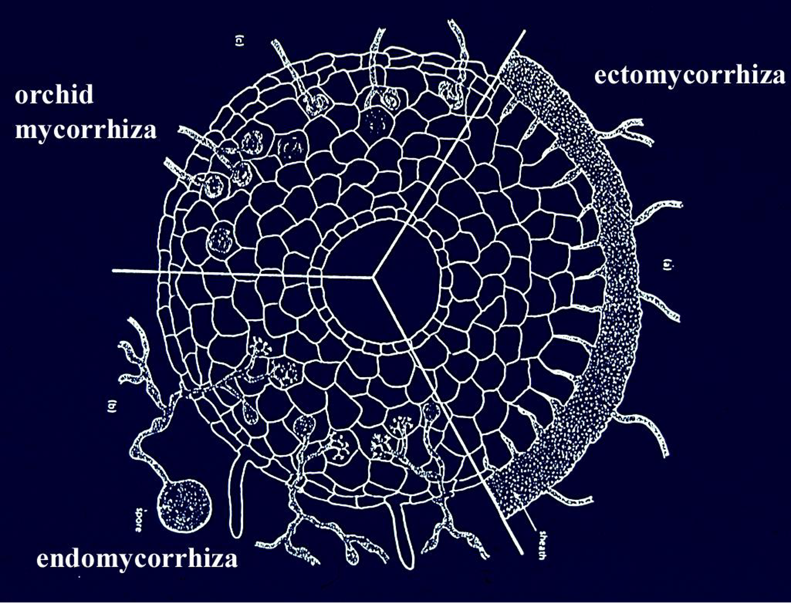
Figure 7.1 Cross section diagram of a plant root infected with different types of mycorrhizal fungi. (A) Ectomycorrhizal, (B) Endomycorrhizal, (C) Orchid mycorrhizae. From Tom Volk

Table 1. Common species of Endomycorrhizae vs Ectomycorrhizae
Endomycorrhizae | Ectomycorrhizae
Funneliformis  Glomus  Rhizophagus  Gigaspora  Planticonsortium | Tuber (Truffle)  Amanita  Laccaria  Boletus  Morchella
Plant associates: Cannabis, most vegetable and herbaceous plants, many grasses | Plant associates: Hardwood and softwood trees, many woody plants

Mycorrhizae Taxonomy
As with many other groups of fungi, the taxonomy of mycorrhizal fungi remains in a state of flux. Species are regularly being renamed or reclassified as our understanding of the fungal kingdom deepens and as our identification techniques improve. Despite this, there are broad taxonomic guidelines that are generally followed.

Endomycorrhizae
Historically, endomycorrhizae were classified within their own phylum, Glomeromycota. However, recent phylogenetic analysis has reclassified them within the subphylum Glomeromycotina under the phylum Mucormycota. Fungi in this subphylum lack septa and are coenocytic, meaning their hyphal cells are multinucleate without divisions between them. Additionally, Glomeromycotina fungi are obligate symbionts of plants. Cultivating these fungi can be challenging because they cannot be cultured in vitro without a host; they must be grown in association with an appropriate plant symbiont. Their spores are produced directly from the mycorrhizal hyphae and are dispersed through the soil, primarily by insects, arthropods, and small mammals. Collecting spores for inoculum production is more difficult than collecting spores from mushrooms, as they are only available after the host plant has grown and died.

Ectomycorrhizal Fungi (ECM)
Ectomycorrhizal (ECM) fungi are typically found in the phyla Basidiomycota and Ascomycota. They generally reproduce through sexual spores, and many ECM fungi produce recognizable mushrooms or underground fruiting bodies, such as truffles. Most deciduous and coniferous trees form associations with ECM fungi, which are found across all types of forests but are particularly diverse and abundant in old-growth forests where the soil has never been disturbed. Other mycorrhizal types, such as Orchid mycorrhizae (Basidiomycota), Ericoid mycorrhizae (Ascomycota), and Monotropoid mycorrhizae (Basidiomycota), also belong to these two phyla. However, there is no evidence that any of these higher fungi form mycorrhizal infections with Cannabis plants.
Table 7.2 Different mycorrhizal groupings and associated characteristics. Character occurrence among grouping indicated by “+,” absence by “-”.
Characters | AM | Ecto | Ecto/endo | Ericoid | Arbutoid | Monotropoid | Orchid
septa | - | + | + | + | + | + | +
Inracellular host colonization | + | - | + | + | + | + | +
Fungal sheath | - | + | +/- | - | +/- | + | -
Hartig Net | - | + | + | - | + | + | -
Fungal taxa | Mucoro- | Mucoro-  Basidio-  Asco- | Basidio | Asco-  Mucoro- | Basidio- | Basidio- | Basidio-
Plant host taxa | Occur across all vascular and non-vascular plants | Gymno- and Angiosperms | Gymno- and Angiosperms | Ericales  Bryophytes | Ericales | Monotropoid | Orchidaceae

Endomycorrhizae
Endomycorrhizae are mutualistic fungi that form associations with many vascular plants. These fungi are considered "generalists" because they are not host-specific and can infect a wide variety of plant species. It is estimated that over 80% of all species of land plants form associations with endomycorrhizae (Schwarzott et al., 2001). Endomycorrhizal fungi are particularly significant in agriculture, as they are commonly associated with short-lived, annual crops like corn, wheat, and many vegetables. These fungi help plants acquire vital nutrients, particularly phosphorus, in exchange for carbon sourced from the plant's photosynthesis.

Classification Challenges
Classifying endomycorrhizal fungi has remained difficult because they cannot be cultured in vitro without a host, making it challenging to study them outside of their natural symbiotic relationships. For many years, it was believed that all endomycorrhizal fungi belonged to the subphylum Glomeromycotina, formerly classified as Glomeromycota (Bruns et al., 2017). Within Glomeromycotina, there are three classes, five orders, 14 families, 29 genera, and approximately 230 species (Oehl et al., 2010). Fungi in this subphylum are often called arbuscular mycorrhizal fungi (AMF) or vesicular arbuscular mycorrhizal fungi (VAM), referring to the tree-like branching structures called arbuscules that form inside the plant root cells (Fig. 7.2).

Emerging Evidence: Mycoromycotina and MFRE
Recent studies have suggested that the sister subphylum to Glomeromycotina, called Mycoromycotina, may also form mycorrhizal relationships with a wide variety of plants (Bonfante and Venice, 2020; Howard et al., 2022). Fungi in Mycoromycotina may form structures called arbuscules, which have historically been misidentified as belonging to Glomeromycotina. The hyphae of Mucoromycotina endophytes, also known as Mucoromycotina Fine Root Endophytes (MFRE), have a distinct characteristic: their hyphae are smaller in diameter (<2 micrometers).
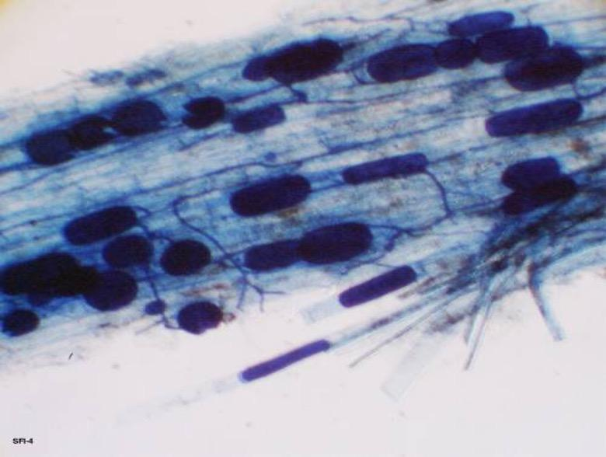
Fig. 7.2 Plant root infected with endomycorrhizae that are producing vesicles, spores, and hyphae penetrating the root and growing in between cortical cells.
There is evidence that MFRE and Glomeromycotina AMF form complementary associations with the same plants, providing different nutritional exchanges. For instance, MFRE are believed to mainly contribute nitrogen to their host plants, whereas Glomeromycotina AMF primarily scavenge phosphorus, both in exchange for carbon from the plant's photosynthesis (Field et al., 2019).

Key Characteristics of Endomycorrhizal Fungi
All Glomeromycotina AMF form arbuscular mycorrhizal associations, and they share certain traits and characteristics:
- Coenocytic hyphae (aseptate, multinucleate)
- Obligate symbiosis (require a host organism to complete their life cycle)
- Spore reproduction (they reproduce by producing spores that are dispersed in the soil)
Mucoromycotina Fine Root Endophytes (MFRE), while similar in some respects (coenocytic hyphae and spore reproduction), are not obligate symbionts. MFRE are facultatively saprophytic, meaning they can survive, grow, and reproduce without a living plant host, unlike AMF, which absolutely require a plant host to complete their life cycle (Field et al., 2015). This saprophytic capability of MFRE opens up opportunities for working with this grouping of fungi in ways that are not possible with obligate symbionts like Glomeromycotina AMF.
Table 3. Hierarchical classification of Arbuscular Mycorrhizal Fungi (Walker et al 2018)
Kingdom | Fungi
Phylum | Mucoromycota | Mucoromycota
Subphylum | Glomeromycotina | Mucoromycotina
Class | Archaeosporomycetes, Glomeromycetes, and Paraglomeromycetes | Mucoromycetes
Order | Archaeosporales, Diversisporales, Gigasporales, Glomerales and Paraglomerales | Endogonales, Mucorales  (Incertae sedis)
Family | Glomeraceae, Gigasporaceae, etc. | Endogonaceae  (Incertae sedis)
Genus | Glomus, Gigaspora, Funneliformis, Rhizophagus, ect. | Planticonsortium
Species | Funneliformis mosseae, Rhizophagus intraradices, ect. | Planticonsortium tenue (Synonym, Glomus tenue)

The mechanism by which a spore finds a root to infect is complex and not fully understood, though scientists know that both the spore and the plant can grow toward each other despite being sessile organisms. Environmental factors such as pH, temperature, microbial community, and nutrient availability are thought to influence spore germination (Giovannetti et al., 2010).
Plants, being sessile, attract beneficial microorganisms by excreting chemicals, mainly carbohydrates and pheromones, from their roots. This area, known as the rhizosphere, fosters a diverse microbial community. Research indicates that many sugars produced by plants through photosynthesis are directed to the roots and released into the rhizosphere to attract microbes (Canarini et al., 2019). By secreting sugars and other compounds, the plant signals compatible organisms like endomycorrhizal fungi to grow toward the root, where the fungal hyphae penetrate the root’s cell wall.
Once the fungus nears the root epidermis, it secretes mucilage and other sticky substances to adhere to the plant (Balestrini and Bonfante, 2014). The fungus senses specific exudates, such as lactones, and its hyphal tip swells, forming a specialized structure called an appressorium or hyphopodium (Genre et al., 2005). This structure assists in establishing the symbiosis and breaks down after penetration. Typically, the fungus enters through a single-celled root hair rather than the root meristem (Bonfante and Genre, 2008). Upon entry, the hyphae travel through the apoplastic pathway to the root cortex, where they form arbuscules to exchange resources with the plant (Genre et al., 2005). These structures increase the surface area for nutrient exchange between the fungus and plant cells.
Endomycorrhizal fungi can also produce vesicles (Fig. 7.2), which are lipid-rich structures thought to serve as nutrient storage during harsh conditions (Müller et al., 2017). The fungal mycelium extends into the soil, secreting acids to solubilize minerals, which it then absorbs and passes onto the host plant. Fungi like AMF can also release glomalin, a compound that deposits carbon into the soil, improving soil structure and contributing to carbon sequestration (Zhu and Miller, 2008).
In addition to enhancing nutrient and moisture uptake, endomycorrhizal fungi can help protect plants like Cannabis from soil-borne pathogens, such as Fusarium and Verticillium species (Benhamou et al., 1994; Liu, 1995). The fungi compete with pathogens for resources, reducing their impact on plant growth and enhancing plant health. They may also trigger plant defense pathways and alter the rhizosphere or root structures (Singh and Giri, 2017).
Another potential benefit for Cannabis growers is the fungi's ability to translocate heavy metals. Research shows that Funneliformis mosseae inoculated plants grown in metal-contaminated soil translocate metals to their shoots, aiding in phytoremediation (Citterio et al., 2005). However, craft growers should be cautious about using AMF in soils with heavy metal contamination, as it may lead to heavy metal accumulation in plant tissues.
Mycorrhizal fungi are also part of a larger mycorrhizal network (MN) that connects plants through their hyphal systems. This network allows plants to send distress signals and share or steal resources from neighbors (Gorzelak et al., 2015). This could benefit growers using raised beds, where multiple plants share a container and thus interact through the mycorrhizal network (Higgins and Hussey, 2019).
However, these networks can be fragile and disturbed by soil tilling. Although fungal spores remain after tilling, it takes time for the fungi to re-establish associations with plant roots (Kabir, 2005). This is one reason some farmers opt for no-till farming, which preserves the mycorrhizal community.

Mycorrhizae in the garden
There are many commercially available mycorrhizae products on the market today. Go into any nursery or super store and there will likely be numerous products that contain various mycorrhizal species. When shopping for the Cannabis plant, it is important to be selecting products that contain endomycorrhizal fungi. The timing of application is also important to increase the effectiveness of the various products.
Many of the products are sold in a dry powder or granular form. We like to use these products whenever transplanting plants. Take some of the dry powder (we like to put the powder in an old seasoning bottle for easy application) and pour directly onto the exposed roots. We will then rub the powder along the roots to ensure even application and that spores will come in direct contact with the roots. When treating large quantities of plants, you may dip and agitate the rootball in a bowl of powdered inocula. These dry products contain the spores of mycorrhizae fungi and/or “propagules.” The propagules are typically root fragments that have previously been colonized by a mycorrhizal fungus which will eventually grow out and colonize the new root zone.
Other products are sold as a wettable powder or as a liquid solution that is meant to be watered in as a soil drench, thus getting the mycorrhizal spores/propagules close to the rhizosphere, or used as a liquid root dip. The liquid products can also be put into a spray bottle and sprayed directly onto roots at time of transplant. Do not spray on any part of the plant besides the roots. The products contain mycorrhizal propagules that will begin to grow and search for roots once watered into the medium. As such, these products can be used to inoculate plants at any time in the growing phase. However, in order to gain the most benefits from mycorrhizae, it is important to inoculate roots when they are young, developing lots of root hairs and branching, and before the plant’s rhizosphere becomes dominated by non-mycorrhizal soil microbes (including potential pathogens).

Important Notes:
- In high phosphorus environments, mycorrhizal associations may not develop and in some instances, the fungus may actually negatively impact the growth of the plant (Ortas 2003). Cannabis growers must be conscious of this when adding bloom boosters or high phosphorus fertilizers if also attempting to utilize mycorrhizae.
- Mycorrhizal fungi may contribute to heavy metal accumulation in the aerial parts of Cannabis if the soil is contaminated.
- Mycorrhizal products may harbor viruses and bacteria. There is currently no viral indexing of mycorrhizal products sold on the market.

By incorporating mycorrhizal fungi into your indoor Cannabis garden, you can increase the tolerance of your plants to abiotic stresses, such as heat and drought, and biotic stressors, including molds and insects (Trouvelot et al. 2015). Plants with mycorrhizal partners are also better at scavenging nutrients and minerals, often leading to larger, more robust, healthier plants.
In an outdoor Cannabis garden it becomes even more important to inoculate plants with mycorrhizal fungi. Depending on the location and past uses of the farm, there may be spores in the soil, yet inoculating plants can improve the infection rate of plants. Outdoor soils typically can have a more diverse microbial community and are often subjected to more stress. Outdoor soil consisting primarily of sand, silt, and clay, also behaves differently (chemically, physically, and biologically) than indoor potting media which is typically peat or coco coir based. Depending on the soil type, many ionic nutrients may be bound to soil particles and mycorrhizal fungi are particularly good at freeing up these elements and making them plant available.
There are very few studies that have documented the benefits of using mycorrhizae in hydroponic systems but there is research being conducted in this area (Ojala and Jarrell 1980, Aini et al. 2019, Caser et al. 2019, Nurbaity et al 2019). Many have reported anecdotal evidence that incorporating these fungi in these systems has benefits, but solid evidence and hard data is somewhat lacking in regards to Cannabis production in hydroponic systems.

Ectomycorrhizae
Ectomycorrhizae (ECM) are the second most common type of mycorrhizal association, though they do not form relationships with Cannabis plants. ECM fungi are typically found in many tree and shrub species and are known for producing large mushrooms, some of which are edible and delicious (like truffles and morels), while others can be toxic or hallucinogenic.
Unlike endomycorrhizal fungi, which all belong to the same phylum, ECM fungi are spread across several phyla, including Basidiomycota, Ascomycota, and, less frequently, Mucoromycota. This indicates that mycorrhizal relationships in ECM fungi have evolved independently multiple times. ECM communities are commonly found in old-growth forests, where they form associations with many tree species. While some ECM species are host-specific, others are generalists and can form relationships with various plant species, sometimes simultaneously. Additionally, multiple fungal species may coexist on different parts of the same plant root.
ECM fungi typically infect plants by developing a fungal sheath (or fungal mantle) around the outside of the root. Some hyphae extend into the soil, while others enter the root but do not penetrate the plant’s cell walls—unlike AMF or MFREfungi, which penetrate the root cells. Instead, ECM fungi form a network of hyphae in the Hartig Net, an intercellular space between plant root cells, which facilitates nutrient exchange similar to the function of arbuscules in endomycorrhizae.
Another key distinction is that ECM fungi generally have septate hyphae, meaning they have cross-walls, unlike the coenocytic (aseptate) hyphae found in AMF and MFRE. The type of septa depends on whether the ECM fungi belong to Basidiomycota (with dolipore septa and clamp connections) or Ascomycota (with simple porate septa).
Like other mycorrhizal relationships, ECM fungi and their host plants both benefit. The plant shares carbohydrates from photosynthesis, while the fungi provide additional water and nutrients. There is also evidence suggesting that ECM fungi can help protect trees from pathogens and communicate with nearby trees through the mycorrhizal network (Gorzelak et al., 2015).
Although ECM fungi are more commonly associated with perennial woody plants and trees, they are not typically found in vegetable or Cannabis gardens. Some companies market products for Cannabis that contain ECM spores, usually of species that associate with woody trees. This is often seen as “label dressing”, where companies attempt to enhance the product's appeal without offering any real benefit, as ECM fungi do not form mycorrhizal associations with Cannabisroots. While ECM fungi play important roles in nutrient cycling in forest ecosystems, they serve little purpose in Cannabis or vegetable gardens, though they may act as saprophytes in these environments.
A Note of Caution
Although the plant-mycorrhizae relationship can be beneficial for both partners, recent research has shown that there could be some potentially damaging consequences of mycorrhizal infection. Miozzi et al. reviewed the current research in 2019 and revealed that in certain situations plants that have mycorrhizal partners may have increased susceptibility to pathogenic viruses, a term they coin “mycorrhiza-induced susceptibility” (MIS). Scientists are still working to understand this phenomenon better and its potential implications. There may even be direct biological risk to endophyte introductions if they carry pathogens themselves (see Chapter 11 on the emerging threat of fungi as hosts and vectors of plant viruses and viroids).
Another study by Garrido et al. showed that increasing the rate of inoculums with Glomus species actually decreased the plants ability to defend itself to herbivory (Garrido et al. 2010). Again the mechanisms here are not yet fully understood but the point here is that under certain circumstances mycorrhizal inoculation may not be the best use of fertilizer dollars. The key is to experiment, observe, and measure the plant response when debating adding any new product into your grow or farm.
Rhizophagy Cycle
The Rhizophagy cycle is a different form of mutualistic symbiosis between plant roots and certain microbes, such as bacteria and yeasts. The term rhizophagy means "root-eating," and it aptly describes the process in which plant roots consume free-living microorganisms, extract nutrients from them, and then expel the microbes back into the soil. This challenges the traditional view of plants as purely autotrophic organisms, as the process incorporates a heterotrophic mechanism of nutrient acquisition (Paungfoo-Lonhienne et al., 2010).
The cycle begins when certain bacteria or yeasts from the rhizosphere (the zone surrounding plant roots) are assimilated into the plant's root cells. Plant-produced reactive oxygen species (ROS) degrade the microbe's cell wall (Fig. 7.4), leaving behind the plasma membrane. This breakdown allows the plant to absorb nutrients that leak from the microbe. Once these nutrients are extracted, the wall-less microorganisms travel towards the root hair cells, causing the root hairs to elongate. This elongation creates an exit route for the microbes to leave the plant, return to the soil, and rebuild their cell walls as they gather more resources to continue the cycle.
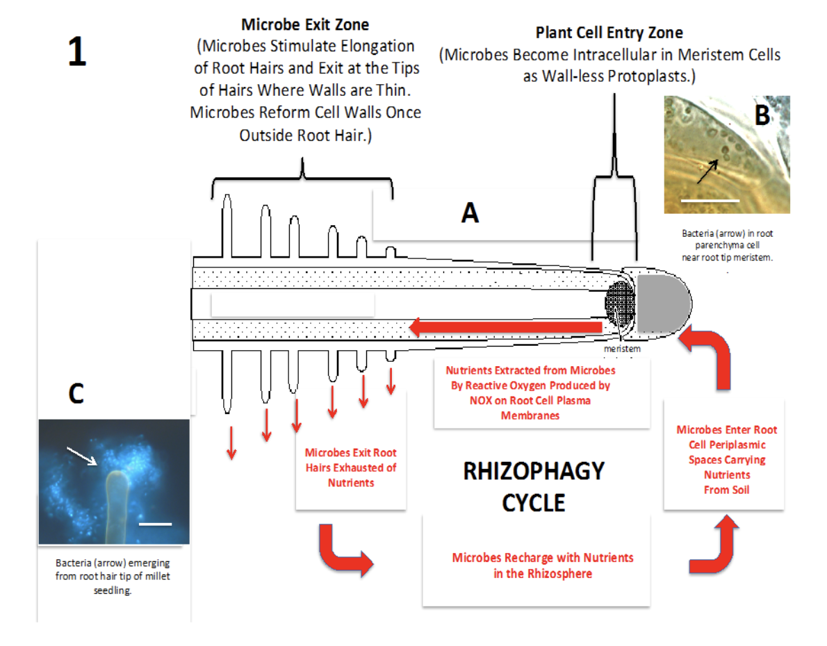
A
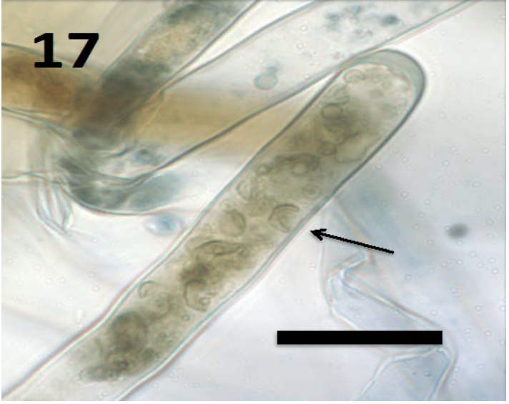
B
Fig 7.3 A) Diagram of rhizophagy cycle in plant root. B) 100x magnification yeast cell inside root hair White et al. 2018
Though it remains unclear how much of a plant's overall nutrient needs are met through rhizophagy, this cycle fundamentally shifts our understanding of plant nutrition. While researchers are still uncertain about whether only specific species of bacteria and fungi can engage in rhizophagy, it appears that most microbes colonizing plant roots are capable of participating in this process (White et al., 2018).
In summary:
- Mycorrhizae is category of a mutualistic relationship between plants and fungi where both partners are benefiting
- Fungi help plants scavenge for resources and in return the plant feeds the fungi with sugars made by the plant during photosynthesis
- Only endomycorrhizae infect Cannabis roots

